

An introduction to plasma diagnostics using a Langmuir probe

John Gresl  
*Department of Physics and Astronomy, University of California Irvine, California 92612, USA*  
Submitted: June 14 2017

# Abstract

A magnetically confined plasma is created in Argon gas using a pulsed RF signal. Several important plasma diagnostics are calculated such as electron density () and electron temperature (). From these diagnostics, several other important plasma parameters can be calculated such as the electron Debye length (), electron cyclotron frequency (), and electron and ion plasma frequencies ( and ). Under a pressure of and a magnetic field of , we report and .

# Introduction

Plasma is one of the four fundamental states of matter and takes up an estimated 99% of the matter in the observable universe. Macroscopically, plasmas are quasineutral mediums of unbound positive and negative charges. In other words, there may be local areas of charge imbalance but the plasma is neutrally charged as a whole. For a given plasma consisting of an arbitrary number of electron and ion species we have our quasineutrality condition which states that the overall charge of the plasma is zero:

where and are the densities and charges of each ion species, respectively.

Harnessing nuclear fusion is one of the prime motivators of studying plasma physics. Nuclear fusion currently produces more energy per amount of fuel than any other fuel source. For instance, one gallon of heavy water (water with all hydrogen atoms replaced with deuterium atoms) produces 10,000 times more energy when fused than a gallon of gasoline. Deuterium-tritium (D-T) plasmas are known as the most efficient plasmas for energy production due to their high mass-to-charge ratio, making it easier to overcome the weak force and fuse together. There are four main reactions that occur in D-T plasmas.

Above, D is a deuterium ion, T is a tritium ion, p is a proton, n is a neutron, and is a nucleus. Hot plasmas capable of studying and sustaining these fusion reactions are energetic enough to destroy anything the plasma contacts1. For this reason, strong magnetic fields are used to shape and contain the plasma within the walls of the vessel. The study of how these magnetic fields interact with the plasma is crucial for creating higher quality magnetically confined plasmas. Measurement of basic plasma diagnostics such as the electron density and electron temperature is first step to studying these effects.

# The Langmuir Probe

Of great importance to us is the Langmuir probe. The Langmuir probe is essentially a wire with one free end in or near the actual plasma. A bias voltage is swept across the tip of the Langmuir probe and the resulting current is measured. At non-zero voltages, a sheath of ions and electrons forms around the probe tip, effectively shielding the rest of the plasma from the effects of the probe tip. The length scale of this sheath is around the order of the electron Debye length, :

where is vacuum permittivity, is the Boltzmann constant, is the electron temperature, is the charge of an electron, and is the electron density. We can simplify this to read2

where is given in meters, is the electron temperature in units of eV, and is the electron density in units of m-3.

For ions to enter the Debye sheath, ions must be travelling at or above the Bohm velocity, , also known as the ion acoustic speed or ion speed of sound. is given by . Here, M is the mass of the ion (assuming a single ion species).

# Experiment

The device consists of two vacuum pumps (one mechanical and one diffusion), a stainless-steel vacuum vessel, a series of solenoidal magnetic coils, an Argon gas supply controlled with a variable leak valve, an amplified RF source, and meters for measuring various pressures, voltages, and currents. A diagram of the device can be found in figure 1.

Figure 1. Cartoon schematic of the device and apparatus. “Diff. Pump” refers to the diffusion pump which allows us to pump down to a much lower vacuum than we would be able to with only a mechanical pump. “SWR Meter” refers to the standing wave ratio meter which measures the forward and reflected power from the RF source to determine how much power is being transmitted by the antenna.

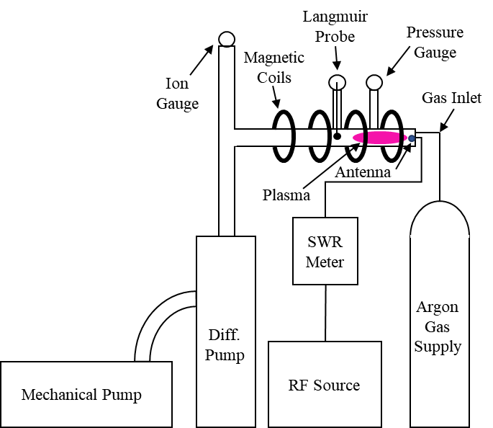

We pumped down the vacuum vessel to a pressure of 5.4 mTorr before introducing the Argon gas. The variable leak valve was adjusted until we achieved a stable pressure of 64 mTorr. The power supply to the magnetic coils was then turned on and the current was adjusted until a magnetic field of roughly 850 Gauss at the vessel’s center was acquired.

We then mixed a radio frequency (RF) with a pulse generator set to generate square waves with the pulse length set to 0.65 ms. This mixed signal was then amplified and sent to the antenna within the vessel to ionize the neutral Argon atoms. We found that we minimized reflected power and maximized transmitted power using a square wave with a frequency of 19 MHz, amplitude of 350 mV (pre-amplification), and a 50% duty cycle. Unfortunately, we did not have the proper equipment to measure the amplitude of the RF signal post-amplification.

A bipolar power supply was then used to sweep positive and negative voltages over the Langmuir probe. The internal resistance of the mixer and also of the scope are of importance. The resistances of the mixer and scope were 211 k and 868 k and will be referred to as and respectively.

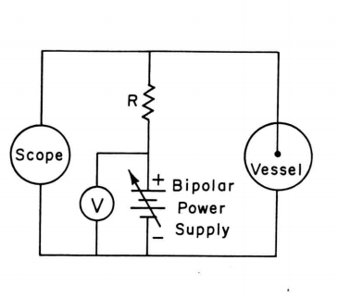

Figure 2. Circuit diagram of our voltage sweeping circuit. R is the resistance of the mixer.

We swept over voltages ranging from -10V to 17.6 V and measured the probe voltages with the scope at each step. Using resistances previously calculated along with the measured probe and bias voltages,  
   
  
  
  
  
  
  
  
  
  
  
  
  
we were able to calculate the total current, , scope current, , and probe current,   
. At large negative voltages, all of the electrons are repelled and an ion saturation current is achieved. We found that our ion saturation current is 6.37 A by looking for a positive plateau in probe current vs. probe voltage. This ion saturation current is then subtracted from the probe current and then plotted.

# Results

We assume that our electrons obey Maxwellian statistics and form a Maxwellian distribution and their density satisfies the Boltzmann relation3

where is the electron density, is a normalization factor, is the charge of the electron, is the potential difference, and is the electron temperature. Taking the natural log of this reveals that the slope of the graph is . We found that the slope of our graph is equal to , giving an electron temperature of . The uncertainty in our measurement stems from statistical deviations from a perfect Maxwellian distribution along with the uncertainty from the linear least squares regression fit.

From this graph, we located the region where a Maxwellian distribution of electron velocities are repelled (boxed in figure 3).

Figure 3. Larger plot: negative probe current vs. probe voltage. Smaller plot: Log of the negative probe current vs. probe voltage. The orange line represents the best fit using a linear least squares regression.

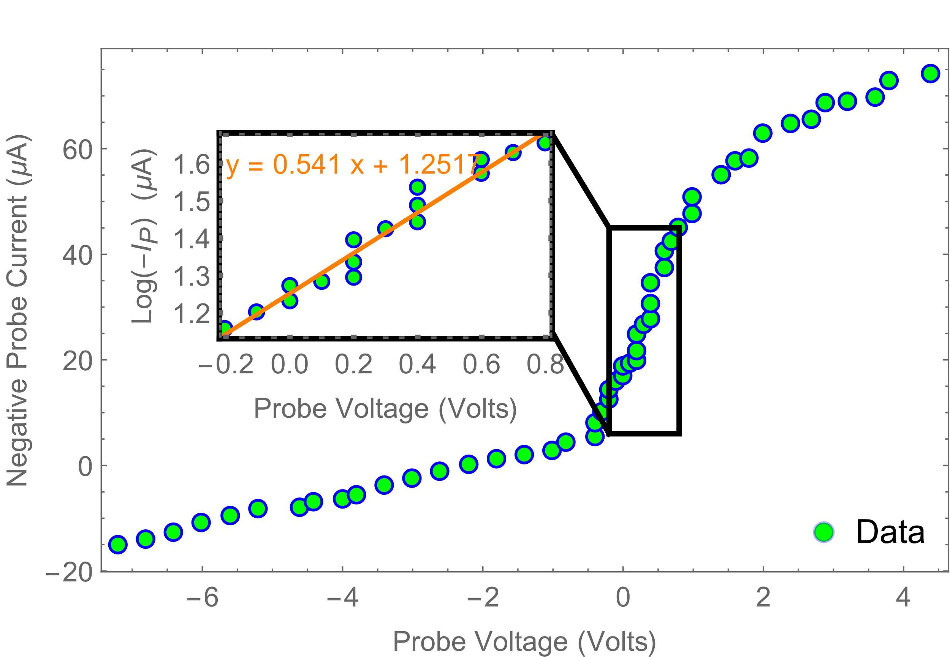

The electron density can be derived from the saturation current and the electron temperature.

where is the surface area of the probe, is the charge of the electron, is our electron density, is the Boltzmann constant, is the electron temperature, and is the mass of an Argon atom. Note that the square root term in is our Bohm velocity, .

Our Langmuir probe consists of a molybdenum disc welded to a tungsten wire with a diameter of 1mm. This gives us an area of or . The mass of an Argon atom is , and the charge of the electron is . Substituting these values into our equation for and recalling our saturation current was yields an electron density of . The uncertainty in this measurement comes from the uncertainty in our electron temperature. Since we are effectively taking the square root of the inverse temperature, we can calculate our uncertainty percent using the formula4

resulting in a 5% uncertainty in our electron density.

# Discussion

The electron temperature and density found in this experiment is typical for a setup of this scale. The effective area of the Langmuir probe is actually larger than its actual area. The sheath formed around the Langmuir probe creates a potential difference which extends past the probes physical boundaries and draws electrons and ions towards it. This causes particles that may not have originally been collected by the probe to fall through the potential well and be collected by the probe. Since electron density is inversely proportional to the probe’s surface area, this under-estimation of the probe’s surface area results in an overestimation of the electron density. Neglecting other effects, the electron density is actually several factors lower than what we have calculated here. Other parameters shown below.

|  |  |
| --- | --- |
| Parameter | Value |
| Electron Mass, |  |
| Ion Mass (Argon), |  |
| Magnetic Field, | 824 Gauss |
| Electron Density, |  |
| Ion (Argon) Density, |  |
| Electron Debye Length, |  |
| Electron Cyclotron Frequency, |  |
| Electron Plasma Frequency, |  |
| Ion (Argon) Plasma Frequency, |  |

The electron cyclotron frequency is the frequency at which the electron experiences cyclotron motion as it gyrates around magnetic field lines. The ion and electron frequencies are a measure of how fast the particular species reacts to changes in the plasma.

Uncertainties are not calculated for these additional plasma parameters since many assumptions were made in deriving their formulas. These assumptions typically do not hold in real world plasmas and the formulas that are produced are mainly used as an order of magnitude estimate on the actual values2.

# Bibliography

1. Heidbrink, W. W. Basic physics of Alfvn instabilities driven by energetic particles in toroidally confined plasmas. *Phys. Plasmas* **15,** (2008).

2. Chen, F. F. *Introduction to Plasma Physics and Controlled Fusion*. (Springer, 1984).

3. Wesson, J. & Campbell, D. J. *Tokamaks*. (OUP Oxford, 2011).

4. Taylor, J. R. *Introduction To Error Analysis: The Study of Uncertainties in Physical Measurements*. (University Science Books, 1997).

# Appendix

**Tips to future experimenters:**

1. It will take *several* attempts to achieve a stable vacuum below 100 mTorr (step 5 in the lab manual).

2. The vacuum equipment may be left running for weeks at a time until you are finished with your experiment. Do not turn off the chilled water supply to the diffusion pump until you have fully completed the *pump-down procedures*.

3. The lab manual is a little confusing when referring to the pulse generator and the RF source. In step 4 under *Data Acquisition*, the pulse length refers to setting the pulse generator, and the duty cycle refers to the RF source.

4. Steps 9 and 10 are reversed under *Data Acquisition*. This should be trivial though since you can’t measure the SWR if there is no input signal to begin with.

5. Carefully monitor the water flow to your magnets. Slightly too much water will result in excess dangerous condensation, and too little water flow will result in the magnets heating up to dangerous temperatures. With the magnets on, the large brown cylinder connected to the water supply should be dry and cold to the touch.

6. It isn’t stated in the lab manual that the RF source should be in the square wave mode, and not sinusoidal. We were able to achieve plasma with both sinusoidal and square waves, but the square wave produced a better SWR.

7. The lab manual incorrectly claims that the plasma has *ignited*, however plasma ignition occurs when the plasma is capable of sustaining its own reactions without external energy being added. Think of the plasma we’ve created as a set of sparks and an actual ignited plasma as a raging forest fire. No man-made reactor has reached ignition, yet. ITER hopes to change this, however.

8. Do not touch or tamper with the antenna feeding into the vacuum vessel (output from the amplifier and SWR meter). Doing so could result in rotating the antenna in a way that causes the antenna to contact with the inner wall, shorting out your system and potentially transmitting a dangerous amount of power into your body if you happen to create a circuit with the vessel.